|  |  |
| --- | --- |
| **Name:** | Muhammad Saim Hameed |
| **Student ID:** | 220256218 |
| **Course:** | BSc. (HONS) Computer Science |
| **Module:** | Individual Project (CS3IP) |
| **Supervisor:** | Hassan Aqeel Khan |
| **Project Title:** | Interface Intelligence: Elevating Design with AI Tools |

**Declaration**

I declare that I have personally prepared this assignment. The work is my own, carried out personally by me unless otherwise stated and has not been generated using paid for assessment writing services or Artificial Intelligence tools unless specified as a clearly stated approved component of the assessment brief. All sources of information, including quotations, are acknowledged by means of the appropriate citations and references. I declare that this work has not gained credit previously for another module at this or another University, save for permitted elements which formed part of an associated proposal linked directly to this submission.

I understand that plagiarism, collusion, copying another student and commissioning (which for the avoidance of doubt includes the use of essay mills and other paid for assessment writing services, as well as unattributed use of work generated by Artificial Intelligence tools) are regarded as offences against the University’s Assessment Regulations and may result in formal disciplinary proceedings.

I understand that by submitting this assessment, I declare myself fit to be able to undertake the assessment and accept the outcome of the assessment as valid."

**Abstract**

"Interface Intelligence: Elevating Design through AI Tools" is an important research report on the interaction of AI and UX design in the quickly evolving field of design. This project aims to revolutionise interface design and set new standards for efficiency and creativity by using AI to enhance the visual appeal and usefulness of user interfaces. The goal of this project is to use AI techniques to optimise and accelerate the creation of visually appealing and highly functional interfaces. Using AI to activities like colour selection, layout development, and user input analysis not only accelerates the design iteration process but also enhances designers' productivity and creativity.

By carefully comparing interfaces made with AI-driven techniques, automated website generators, and manual design methods, the project establishes the most effective interface design tactics. The results aim to set new standards in the fields of AI and UX design by showing how AI tools may be integrated into design paradigms and forecasting the development of design processes that are more focused on users, intuitive, and efficient.

**Index Terms**

Artificial Intelligence (AI)

User Experience (UX) Design

Interface Design

Design Automation

User Interface (UI) Aesthetics

Design Efficiency

Comparative Evaluation

Automated Layout Generation

AI in Creativity

Human-Computer Interaction (HCI)

Color Theory in Design

Usability Testing

AI Algorithms for Design

Design Innovation

Digital Product Development

**Acknowledgements**

I would like to express my gratitude to my supervisor, Dr. Hassan Aqeel, for all of his assistance, guidance, and support throughout my project, "Interface Intelligence: Elevating Design through AI Tools." Dr. Aqeel's helpful guidance and constructive criticism have been important in the project's development and success. I also want to thank the several academic and online communities that have helped to improve the level of detail of my work by providing priceless resources and opinions. Their help improved my entire study experience and opened up a lot of new research opportunities for me.

**TABLE OF CONTENTS**

Section I: Introduction 8

A. Problem Statement 10

B. Aims and Objectives 10

C. Organisation 10

Section II: Related Work 11

A. Literature Review 11

ii. Advancing User Interface Design using Computational Methods 11

iii. Using Computational Saliency Models for Webpage Design 11

iv. Research into Automated User Interface (UI) Creation 12

Section III: Methodology 12

A. Automated Website Tools for UI Generation 13

i. Uizard 13

i. Webador 13

ii. Chatgpt 4 and 3.5 13

B. AI Analytical Tools for User Interface (UI) Evaluation 14

i. Aalto Metrics Interface (AIM) 14

Limitations 14

ii. Saliency Tool 14

Limitations 15

iii. Nima Score 15

Limitations 15

Section IV: Showcase 16

A. Uizard generated design. 16

i. The development of a wire frame furniture web page 16

iii. Inventive Furniture Homepage Designs 18

B. Webador: The Ultimate Homepage Builder 20

A. ChatGPT 3.5 Customized Furniture Shopping Platform 22

A. ChatGPT 4.0 Customized Furniture Shopping Platform 23

Section V: Experiments and Results 24

A. AIM Tool for investigation and analysis 24

i. Uizard Metrics Evaluation 24

ii. Webador Metrics Evaluation 25

iii. ChatGPT 3.5 Metrics Evaluation 26

iv. ChatGPT 4.0 Metrics Evaluation 27

B. Exploring Saliency Detection Tool & Maps 27

i.Uizard 28

ii. Webador 29

iii. ChatGPT 3.5 30

iv. ChatGPT 4.0 31

C. NIMA SCORE 32

4. Project Monitoring, Planning & Reflection 33

4.1 SMART Objective 33

4.2 Project Plan 33

4.3 Gantt Chart 35

4.4 Project Break down Structure (PBS) 36

Section V: Discussion 37

I.Uizard: Revolutionizing Rapid Prototyping 37

I.Webador: Simplifying Web Design for All 38

I. ChatGPT: Bridging Design and Development 39

I. Aalto Interface Metrics (AIM) 39

I. Saliency Tool 40

I. Neural Image Assessment (NIMA) 40

Section VI: Conclusion 41

I. Objectives Achieved 41

References 43

Related Links 47

Appendix 1: ChatGpt 4.0 47

Appendix 2: ChatGpt 3.5 51

Appendix 3: Saliency Code‌ 55

**TABLE OF FIGURES**

*Figure* 1  *Uizard Wire frame Trending Designs and Search Functionality* 16

*Figure* 2  *Uizard Wire frame Layout for Product Categories Section* 17

*Figure* 3  *Uizard Wire frame of Exclusive Deals and Popular Picks in Furniture Retail* 17

*Figure* 4  *Uizard Wire frame Preview for Visit Our Blog* 18

*Figure* 5  *Furniture Home Page design by Uizard generation tool* 19

*Figure* 6  *Home Page Informative Blog Section by Uizard tool* 20

*Figure* 7  *Furniture Home Page layout generated by Webador* 21

*Figure* 8  *personalised furniture home pages built by ChatGPT 3.5* 22

*Figure* 9  *customised furniture homepage developed with ChatGPT 4.0* 23

# Section I: Introduction

Creating user interfaces that are both simple and engaging has become essential to enhancing the user experience in today's changing digital environment. A new approach that makes use of artificial intelligence rewrites the laws on design efficiency and aesthetic appeal. This programme aims to automate and optimise the design process by combining AI-driven techniques with conventional design practises. The field of interface design is about to enter a new era where creativity is enabled by technological advancements to create highly useful and aesthetically pleasing interfaces through faster iterations and better design choices. The project expedites the design work flow and opens up new avenues for creative user interface design.

Any software system must have an interface since it is the primary means of serving the end user. An application's interface impacts how a user sees it, and how simple and easy it is to use often influences the user's decision to utilise it (Kurzantseva, 2007). The features of the target audience must be taken into account while developing software and its user interface. User learning preferences can be carefully considered when artificial intelligence components are integrated into application design. The development of adaptive interfaces has been encouraged by the rapid expansion of features in contemporary software systems. (Tagirova and Zubkova, 2019).

Since the dawn of computing technology, the domains of artificial intelligence (AI) and human-computer interaction (HCI) have been interconnected. Despite being within the field of computer science, HCI and AI have a complex and sometimes hostile connection. HCI seeks to increase people's capacity to use and profit from computers, whereas AI attempts to imitate human thought processes within computer systems. (Lieberman, 2009) This research study looks at the objectives of HCI and AI to better understand how integrating artificial intelligence might improve user interface usability and functionality. This is an initial move in the direction of bettering computer-human interaction.

Since creativity has made it possible for humans to create and innovate in a wide range of fields, it has always been crucial to the advancement of human development. (Quaresma & Ruiz, 2021). These kinds of innovative efforts have sparked important discoveries and made it possible to hunt for increasingly advanced artificial intelligence-based technology. (Gonçalves, Oliveira, and Nunes, n.d.)

Based on user preferences, generative AI automatically generates a variety of layouts, colour palettes, and interactive components, revolutionising web design and interface development. Through the application of machine learning techniques, it provides dynamic, customised interfaces that adapt in real-time, optimise code efficiency, and enhance user experience. Designers can use their limitless creativity and speed up the development process with the aid of this state-of-the-art technology, producing elegant and extremely functional digital experiences. Beyond design, generative AI produces text, images, audio, and video content, enhancing digital environments with diversity and originality. (Nah et al., 2023) state that ChatGPT is a shining example of generative AI, which has significant potential in a range of sectors, including business, healthcare, education, and content creation. Here, we look at a few instances of its use in these fields.

Taking advantage of this progress, automated open-source websites enable the production of User Interfaces (UI) quickly and with considerable time and resource savings. Generative AI has been integrated into web development processes through the use of cutting-edge tools like Uizard (uizard.io, n.d.) and Webador (Webador, n.d.). ChatGPT versions 4 and 3.5 (OpenAI, 2023) are utilised to further enhance this process. ChatGPT distinguishes itself by generating configurable user interface code, in contrast to other platforms that generate final products immediately. Because of its scope, interface designs can be more specifically tailored to meet the demands of certain users.

To enhance interface evaluation, the project includes analytical techniques based on artificial intelligence. Essential methods for assessing the visual attractiveness and usefulness of these interfaces are saliency maps, Neural Image Assessment (NIMA) ratings (Talebi and Milanfar, 2018), and Aalto Interface Metrics (AIM) (interfacemetrics.aalto.fi, n.d.). These AI-driven analyses look at visual appeal and user engagement to find areas that may be optimised to enhance the user experience. This stepwise approach helps UI designers understand how AI technologies might enhance interface design by outlining both the advantages and challenges of applying these tools to interface design.

Each of these tools has capabilities designed specifically for creating prototypes, websites, and thoughtful user interfaces. We'll be closely monitoring these interfaces to see how effective they are, paying special attention to usability and layout efficiency. In addition to providing UI designers with important insights into the advantages and possible drawbacks of utilising AI-powered technologies in interface creation, the analysis aims to identify areas for improvement and assess their impact on user experience.

To enhance the efficiency and creative abilities of user interface designers, this project tackles the crucial issue of identifying and exploiting state-of-the-art tools that can significantly accelerate the interface design process. It satisfies the urgent desire to look into AI-powered solutions that enhance the quality of user interfaces and shorten the development cycle, helping designers create more engaging and user-focused digital experiences.

## Problem Statement

This research project aims to investigate the potential revolutionary effects of introducing state-of-the-art generative AI techniques into the field of user interface (UI) design. The project's particular goal is to evaluate Uizard, Webador, and ChatGPT's performance as tools for accelerating UI development without compromising quality. Furthermore, it looks into how human analysis and AI-driven analysis may support one another to maximise customer experience results in the ever-evolving digital ecosystem.

## Aims and Objectives

The project aims to change interface design through the use of artificial intelligence (AI) by increasing aesthetics, usability, and efficiency. The particular objectives are as follows:

* AI approaches will be used for the development and enhancement of interface design prototypes to guarantee that they fulfil high standards of user experience and design quality.
* The review process can be enhanced by using artificial intelligence (AI) analytical tools, which provide a thorough analysis of interface performance on several parameters such as usability, visual appeal, and user engagement.
* The objective of Automated Design Improvement is to continuously improve interface designs in response to user input and analytical assessments by utilising AI-generated insights to construct automated refinement techniques.

## Organisation

The first section of the study paper examines how artificial intelligence (AI) can improve user interface design, increasing its effectiveness and aesthetic appeal. After that, it examines previous research on the relationship between AI and UI design, highlighting gaps in the field. The technique section discusses the creation and evaluation of user interfaces utilising AI technologies such as Uizard, Webador, and ChatGPT. To demonstrate the benefit of AI in design, real-world examples are shown. This study discusses the results and difficulties experienced while evaluating these AI-created interfaces for usability and effectiveness. In order to fully utilise AI, it concludes by making recommendations for future research directions and ways to improve AI's integration into the design process.

# Section II: Related Work

## Literature Review

**i. Study of User Experience and User-Centred Design Interaction**

The literature study looks at the relationship between the ideas of User-Centered Design (UCD), User Experience (UX), Artificial Intelligence (AI) tools, and the use of analytical techniques to improve User Interfaces (UIs). This section explains the history and current state of these fields, which helps us achieve our project's goal of combining AI breakthroughs and analytical insights with user-focused concepts to create interfaces that succeed in usability and engagement. This foundation supports our research into how technology may enhance interface design and user engagement.

The User-Centered Design (UCD) approach was used because to its emphasis on creating interfaces that meet the specific needs of people (Duvaud et al., 2021). In order to gain an in-depth analysis of the target user base and their software interaction experiences, this method integrates user research (UR) into the design process. Since it began in the 1980s in Donald Norman's research lab at the University of California, San Diego (UCSD), UCD has developed into a crucial component of improving user experience (UX) with technology (Norman & Draper, 1986). (Cen and others, 2023).

## ii. Advancing User Interface Design using Computational Methods

The advancement of computational techniques and design tools has opened up new opportunities for supporting the creative processes of user interface (UI) designers. Rather than automating or replacing the design process, these methods are meant to assist it. According to studies done by designers, there are several challenges in UI design, especially because to the size of the design spaces that need to be considered (Hegemann et al., 2023). Using fresh research prototypes, the User Interfaces group at Aalto University conducted a lab demo to improve designers' creative and problem-solving abilities in UI design.

The exhibition highlighted the challenges associated with user interface design, including large design areas, unclear objectives, presumptions, and a wide range of needs. Six computational features, such as Figma plug-ins that used machine learning methods like deep neural networks, Bayesian inference, and natural language processing (NLP) that were based on empirical evaluations with the designers, were showcased in real time. (Hegemann and colleagues, 2023)

## iii. Using Computational Saliency Models for Webpage Design

Presently, eye tracking data is used by designers to identify fixated regions, which is essential for understanding attention allocation. A computational saliency model's prediction of likely fixation points helps designers in maximising the impact and engagement of visual elements. The study's experimental objective was to determine the saliency model's utility in web page development. Eye tracking data was collected when participants viewed the fifty web page screenshots that were created. The findings demonstrated that the saliency model correctly predicted areas of fixation within web page interfaces. This suggests that when building web pages, using computer models rather than eye tracking to identify visually appealing places can be a more cost-effective solution.

(Van Den Bergh et al., 2010). Thus, the basic idea is that visual saliency directs the eye to regions of an image, thus accelerating processing speed. (Query View Transformation, OMG Standard, 2010).

## iv. Research into Automated User Interface (UI) Creation

The technique for automating the design of user interfaces using the UIProtocol notation for both input and output is explained in the article. Its objectives were to simplify design, maintain consistency, and make interface creation less complicated. The system used combinatoric optimisation to assess different interface elements and identify the best possible design. Subsequent advancements will centre on enhancing optimisation and considering the target platform and user context, in addition to strategies to leverage strong computational capacity for complex computations (Macik, n.d.).

**v**. **Opportunities for research and current literature Gaps**

The topic of User Interface (UI) design is a rapidly developing area that has an extensive number of study opportunities due to the integration of computational methods and artificial intelligence (AI). However, there are notable gaps in the current body of literature. While the field of AI-related design enhancement is still in its early stages of investigation, there is a lack of comprehensive study on the effects of these technologies on designers' creativity, user pleasure, and overall aesthetic efficiency in real-world applications. More study is needed to fill in these knowledge gaps, particularly to understand the long-term impacts of AI-assisted design tools on the creative process and how adaptable they are to different design settings. The subject of UI design could advance if better user-centred, intuitive design processes and tools were developed because of this inquiry.

# Section III: Methodology

The approach utilised in this study is precisely developed to maintain consistency by focusing on the building of user interfaces (UI) with powerful automated tools like as Uizard and Webador, as well as the programming capabilities of Chat GPT versions 3.5 and 4.0. (Open AI, 2023). Using these technologies, the purpose is to evaluate the usability, effectiveness, and visual appeal of the interfaces using AI analytical techniques to gain a full understanding of potential changes.

To establish a uniform evaluation framework, all UI designs generated for this project are based on the same theme, a custom furniture selling website. This theme ensures that the evaluation and design techniques are consistent with specific industry criteria, allowing for a focused examination of the interfaces' capacity to fulfil the specific requirements of online furniture sales.

The purpose of applying AI analytical techniques such as saliency maps, Aalto Interface Metrics (AIM) (interfacemetrics.aalto.fi, n.d.), and Neural Image Assessment (NIMA) scores is to completely evaluate the success of created user interface designs.The study use these analytical methods to determine where the UI designs excel and where they need to be improved, with the ultimate goal of improving the user experience on the bespoke furniture website.

## A. Automated Website Tools for UI Generation

## i. Uizard

Uizard, an automated tool for innovation, aims to revolutionise the process of building user interfaces (UI). With its simple drag-and-drop interface and intelligent design elements, it employs artificial intelligence to enable designers and non-designers to swiftly translate ideas into workable UI prototypes, speeding up the design process.

In this project, Uizard was critical in developing a user interface designed specifically for a furniture-selling website. Uizard used its AI-driven design skills to produce an aesthetically beautiful and exceptionally useful user interface (UI) by inputting aesthetic and functional demands specific to the furniture sector. This approach demonstrated Uizard's ability to provide industry-specific design solutions while simultaneously simplifying the design phase and ensuring that the final interface was closely aligned with the project's theme goal of custom furniture sales (uizard.io, n.d).

## Webador

Webador is a user-friendly computerised website builder that enables individuals and organisations to create professional-looking web pages without the need for coding skills. It is the ideal solution for rapidly and easily constructing unique websites because it has a huge number of easily configurable templates and design components.

Webador was helpful in developing a user interface for this project that was fit to the specific needs of a platform that sells furniture. Webador's easy-to-use design tools and templates enabled the creation of an unique, visually appealing user interface (UI) that integrated utility with the furniture industry concept. This simplified the design process and ensured that the final interface met the project's specific requirements while also improving the online shopping experience for customers looking for custom furniture (Webador, n.d.).

## Chatgpt 4 and 3.5

ChatGPT is an advanced language generation model created by OpenAI that is well-known for its capacity to understand and generate human-like response from input. This AI-powered tool is great at producing detailed response, generating code, and answering difficult questions. ChatGPT is a versatile platform that developers and designers may utilise to include advanced AI capabilities into their projects. It can be used to generate code and convey design ideas related to user interface design.

ChatGPT versions 3.5 and 4.0 were necessary for this project in order to create the code for the user interface of a custom furniture selling website. ChatGPT received thorough requirements outlining the platform's specific functionality, appearance, and user interface. ChatGPT then turned the specs into precise code guidelines. The produced code was then loaded into an Integrated Development Environment (IDE) to produce the user interface. After the code was developed, it was updated and refined to ensure that the final user interface (UI) fully met the project's goal of providing a simple and joyful furniture purchasing experience (OpenAI, 2023).

## B. AI Analytical Tools for User Interface (UI) Evaluation

## Aalto Metrics Interface (AIM)

AIM is an open-source code repository and web platform for computing the effectiveness of graphical user interface (GUI) designs. It brings together a variety of measurements and models from previous publications, all of which have been scientifically proven to predict how users will perceive a design, search for material, and react to it aesthetically (Antti Oulasvirta et al., 2018). AIM's major purpose is to promote the acceptance and implementation of computational techniques in design procedures. Computational modelling has a secondary function in interface and interaction design, where evaluations are usually based on personal experience and empirical judgements (Antti Oulasvirta et al., 2018).

The Aalto Interface Metrics (AIM) analytical tool was used in this project to evaluate the usefulness of the user interface for a custom furniture sales website. After receiving pictures of the website's user interface, AIM assessed its usability, aesthetic attractiveness, and user engagement using a variety of criteria. The AIM feedback enabled targeted changes to the furniture platform's overall user experience by providing statistical data on how well the UI followed to design and usability criteria.

## Limitations

Although the AIM tool is uncommon in its use of computational approaches to judge designs, it has limitations. One of its key flaws is that it relies on preset measurements that may not adequately reflect the specifics of user experience or the arbitrary components of design aesthetics. Furthermore, AIM's usefulness is dependent on the accuracy and significance of the data submitted, which may limit its application to a wide range of odd or diversified design tasks. Furthermore, the instrument may not adequately address the dynamic interactions that occur between customers and interfaces, potentially missing contextual factors that influence usability and engagement. These drawbacks highlight the importance of using extra assessment approaches to evaluate interface designs in their whole.

## Saliency Tool

In prior research, a prominent strategy for improving system understanding was to build "saliency maps" or "heat maps," which highlight the essential pixels in the picture classification process (Lapuschkin et al2019). These explanations, it is said, are simple for users of all skill levels to understand, making it easier to detect abnormalities in system activity and creating a healthy level of system trust (Ribeiro, Singh, and Guestrin 2016). Saliency maps are utilised in a variety of applications, including predicting the parts of an image where human eyes are most likely to focus (Alqaraawi et al., 2020).

Saliency maps were critical in this research analysis and the redesign of the bespoke furniture website's user experience. These saliency maps were built with Python code that called methods from the OpenCV package, a well-known resource for computer vision applications. The research was able to make data-driven improvements by employing saliency detection to determine which UI elements were most likely to stimulate users' interest. This technique reduced the user interface and boosted user interaction and engagement by ensuring that critical components of the furniture selling platform were immediately visible and consistent with user behaviour patterns.

## Limitations

Saliency maps have basic limitations, despite being a useful tool for identifying key portions of an image for classification purposes. One of their key issues is that they tend to oversimplify complex models' decision-making processes, potentially hide the deep interactions between factors that influence a model's output. Furthermore, saliency map understanding can be highly subjective, varying widely between users and not necessarily accurately representing the model's underlying logic. This calls into question the validity of saliency maps' ability to provide precise and meaningful insights into model behaviour by producing misinterpretations of what the model of behaviour has learned.

## iii. Nima Score

It has always been difficult to determine aesthetics and image quality in the fields of computer vision and image processing. The process of evaluating technical quality focuses on identifying tiny faults such as compression artefacts, noise, and blur. The purpose of aesthetic evaluation, on the other hand, is to quantify higher-level semantic aspects linked with sentiments and beauty in images (ieeexplore.ieee.org, n.d.). The Neural Image Assessment (NIMA) score is an innovative approach to evaluating image quality that combines artistic judgement with technical accuracy. This metric evaluates visual excellence in depth, using complex artificial neural networks to assess an image's technical features as well as its emotional and aesthetic appeal.

In this study, the visual appeal of the user interface designed for a website selling custom furniture was quantitatively evaluated using the Neural Image Assessment (NIMA) score. The NIMA system uses powerful machine learning models to generate objective, numerical rankings for visual appeal and design efficiency based on UI graphics. These scores helped to identify areas where the visual aspects of the user interface (UI) may be improved. They also supervised subsequent changes to ensure that the interface not only met its functional requirements but also achieved a high level of visual perfection, which is critical for maintaining and attracting users on the platform.

## Limitations

Although the Neural picture Assessment (NIMA) score is an unusual way for evaluating picture quality and aesthetics, it is not without limitations. Its reliance on training data is a significant challenge because it may add biases towards specific aesthetic standards while potentially ignoring other cultural or subjective views of beauty. Furthermore, NIMA scores may fall short of illustrating an image's emotional effect or contextual relevance, both of which are highly subjective and vary widely among viewers. This limitation highlights the importance of applying NIMA with sensitivity and human judgement, especially in circumstances when a complete understanding of the image's content and a targeted audience is required.

# Section IV: Showcase

## A. Uizard generated design.

## The development of a wire frame furniture web page

Uizard's ability to build wire frame models was proved when developing the home page prototype for a furniture-selling website. Uizard talent developed a wire frame model that accurately matched the layout of the homepage after entering specific specifications and selecting a chosen design aesthetic. This early prototype served as a visual blueprint for later stages of user interface development, highlighting the ideal location of key features such as calls to action, product displays, and navigation bars. This feature of Uizard highlights how valuable it is for taking conceptual design thoughts and converting them into structured, usable prototypes, so speeding up the design process from start to finish.

Uizard demonstrated its versatility by constructing three separate wire frame models for the furniture selling website in the following order: a homepage display, a product category page, and a blog display page. Every model was carefully developed, with the blog display giving users with engaging material, the product category page organising products for easy browsing, and the homepage serving as a welcoming entry point. Uizard's tiered approach effectively defined the website's core elements, laying the framework for a solid and easy-to-navigate online presence.

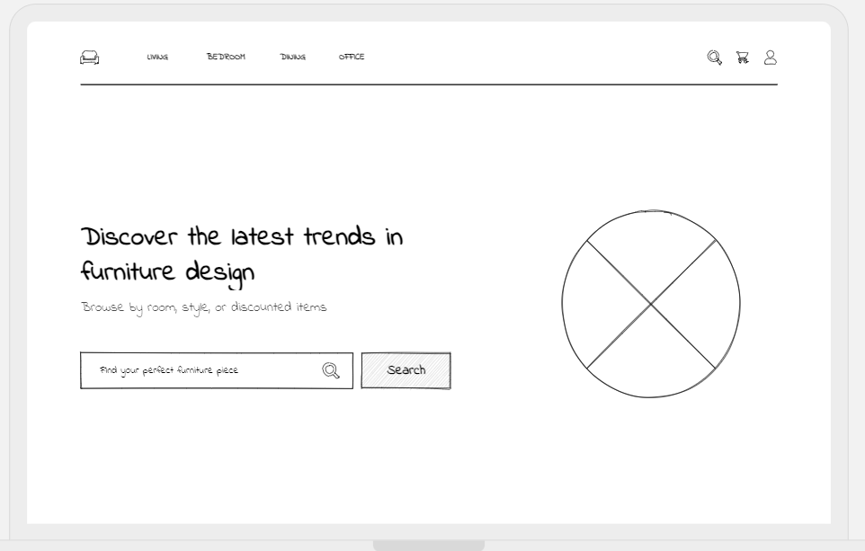

***Figure 1*** ***Uizard Wire frame Trending Designs and Search Functionality***

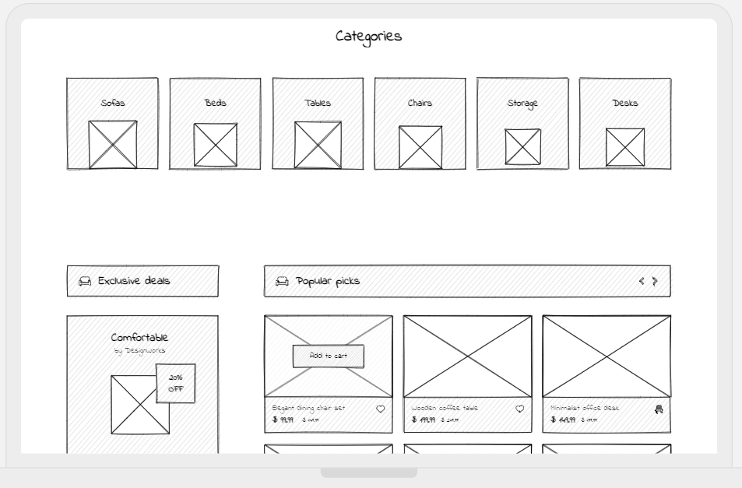

***Figure 2*** ***Uizard Wire frame Layout for Product Categories Section***

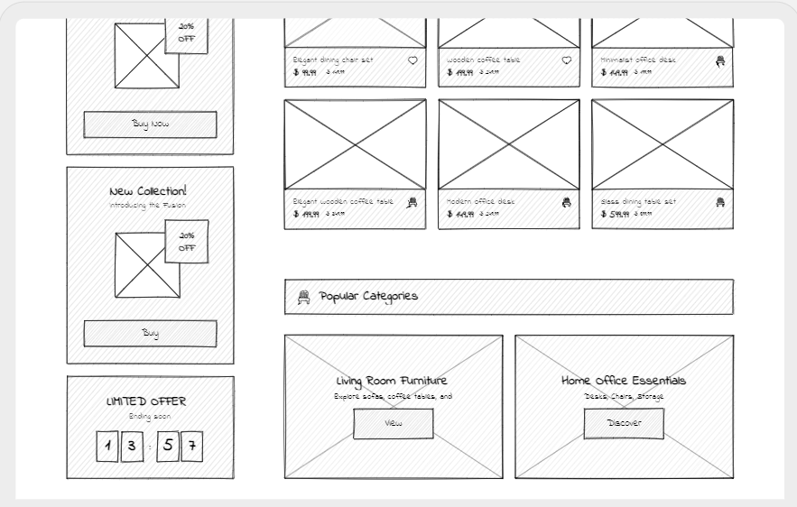

***Figure 3*** ***Uizard Wire frame of Exclusive Deals and Popular Picks in Furniture Retail***

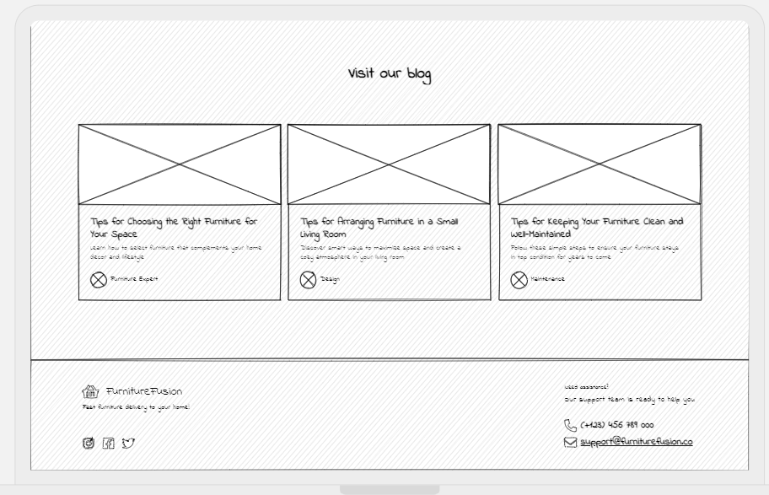

***Figure 4*** ***Uizard Wire frame Preview for Visit Our Blog***

## Inventive Furniture Homepage Designs

This project successfully tested Uizard's tricky capabilities by transforming wire frame models into fully developed design interfaces for a furniture-selling website. The tool successfully transformed the wire frame concept into a polished, user-friendly homepage complete with eye-catching graphics and useful elements that mirrored the original design blueprint. Uizard's careful attention to detail ensured that the wire frame's key aspects were kept, resulting in a coherent and visually appealing user interface that effectively connects the concept to the user experience. This technique shows Uizard's ability to not only understand but also execute UI designs with a high degree of creativity.

The seamless production of a detailed display for a website offering custom furniture, beginning with a welcoming homepage that nearly resembled the wire frame's smart layout, demonstrated Uizard's designer abilities. Subsequently, the platform expertly designed a large product category sector, complete with an attractive search bar that allows for seamless navigation. The construction of an engaging blog section, which brought the information envisioned in the original wire frames to life, marked the end of the design phase. Uizard's flawless execution of these critical UI components illustrates its effectiveness in creating a unified and engaging online purchasing experience.

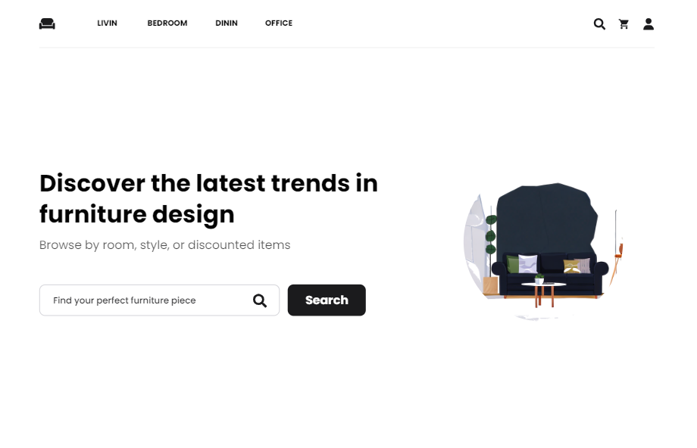

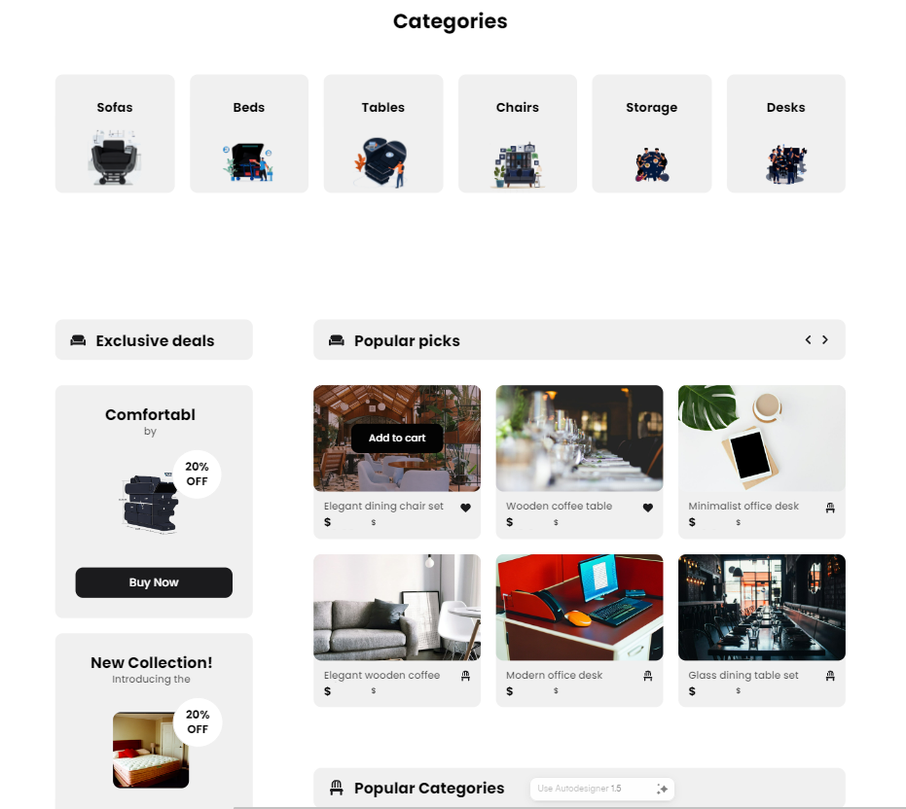

***Figure 5*** ***Furniture Home Page design by Uizard generation tool***



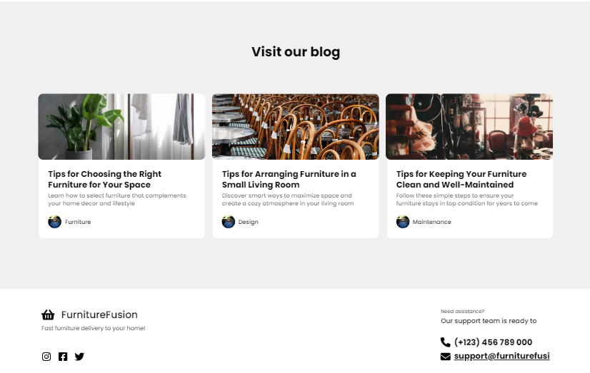

***Figure 6*** ***Home Page Informative Blog Section by Uizard tool***

## B. Webador: The Ultimate Homepage Builder

Using Webador's user-friendly design platform, specifications were entered to generate a working model of a furniture-selling website, with a focus on the homepage's user interface. Webador successfully turned these inputs into a working model that not only functioned correctly but also brilliantly captured the homepage's UI style, proving its strong ability to bring design concepts to life. This method demonstrated the platform's ability to plan and execute the home page's UI design with precision, ensuring that the first point of user interaction reflected the major goals of the project's design phase while also being aesthetically pleasing and logically functional.

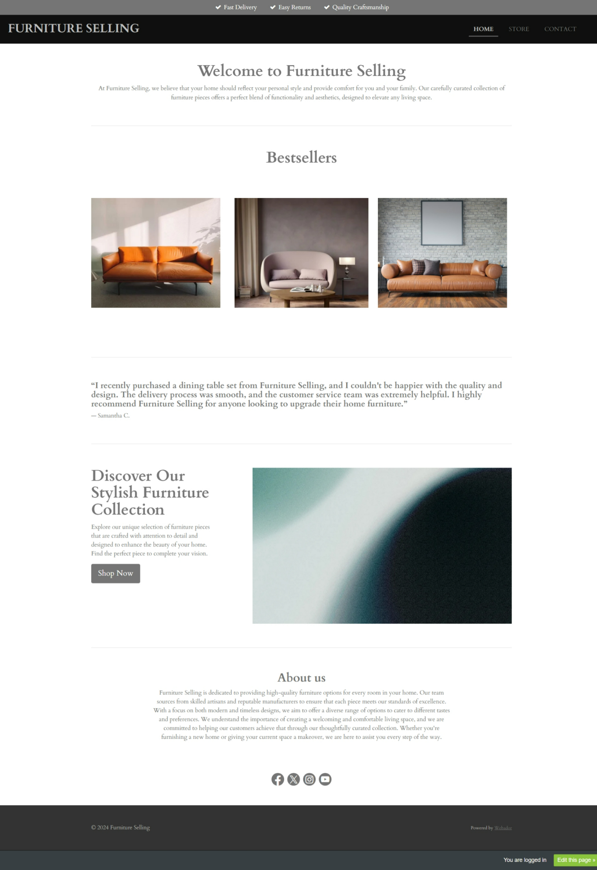

***Figure 7*** ***Furniture Home Page layout generated by Webador***

## A. ChatGPT 3.5 Customized Furniture Shopping Platform

The HTML and CSS code for the furniture store's homepage was created by entering specific instructions and utilising ChatGPT 3.5's extensive language model capabilities. The end result is an indication to the AI's understanding of web design principles: it generates a technically sound page with clean, well-structured code and an elegant layout that highlights products.   
  
According to our analysis, ChatGPT 3.5 did an excellent job of turning the design brief into a user-friendly interface. The AI produces a user-friendly navigation system with visually appealing product displays that achieve an ideal balance between functionality and aesthetics. The model's generated code was used to create high-quality photos and make effective use of white space to showcase product characteristics.

ChatGPT 3.5's homepage features a user-friendly interface and a simple, clean layout. High-resolution images and clear pricing information draw attention to the highlighted products, which are shown front and centre. The use of neutral tones and plenty of white space ensures a user-friendly experience, emphasising the furniture and making navigating simple. The design effectively balances practicality and aesthetic appeal, presenting the products in an easy-to-use and understanding manner.

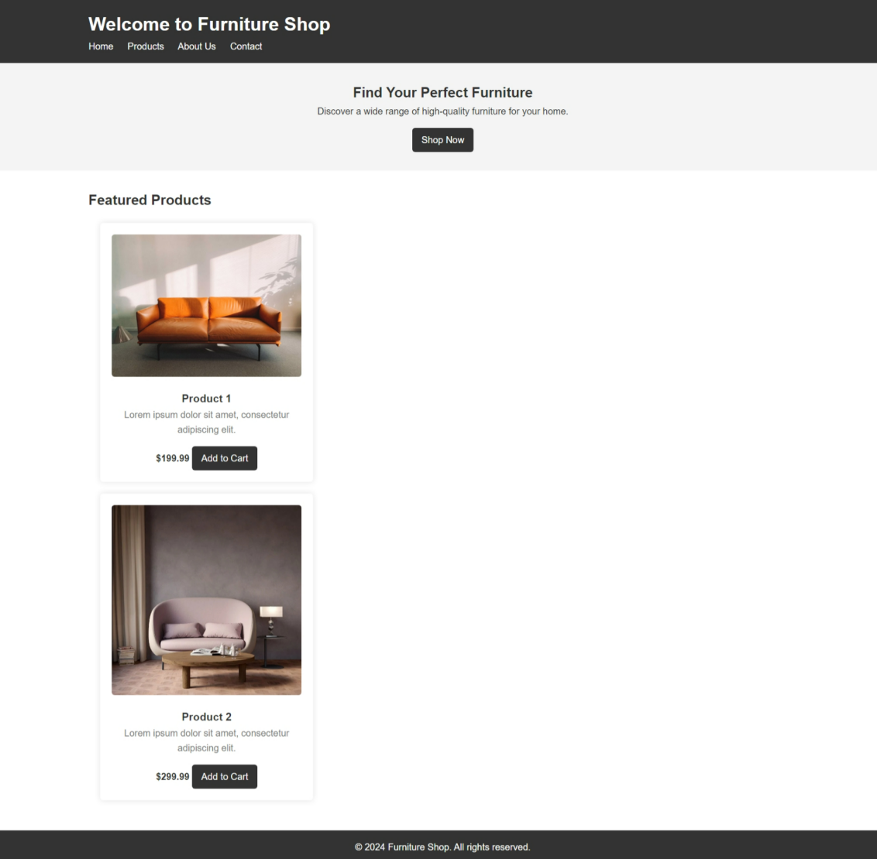

***Figure 8*** ***personalised furniture home pages built by ChatGPT 3.5***

## A. ChatGPT 4.0 Customized Furniture Shopping Platform

Using the expanded features of ChatGPT 4.0, we designed a smart internet-based furniture store home page. The platform's ability to comprehend design transformed provided details into a visually appealing and intuitive user experience. The final homepage captures the essence of the project, providing easy navigation and interaction while also highlighting the clean elegance of contemporary furniture design. The user interface (UI) of ChatGPT 4.0 is so effectively executed that the first interaction is visually appealing and simple to use.

The clean layout and mild colour palette of the homepage design highlights the furniture photographs while ensuring a user-friendly browsing experience. Simple call-to-action buttons and clear navigation boosts user engagement. Overall, the layout achieves the appropriate mix between design and function to capture and maintain clients' attention.

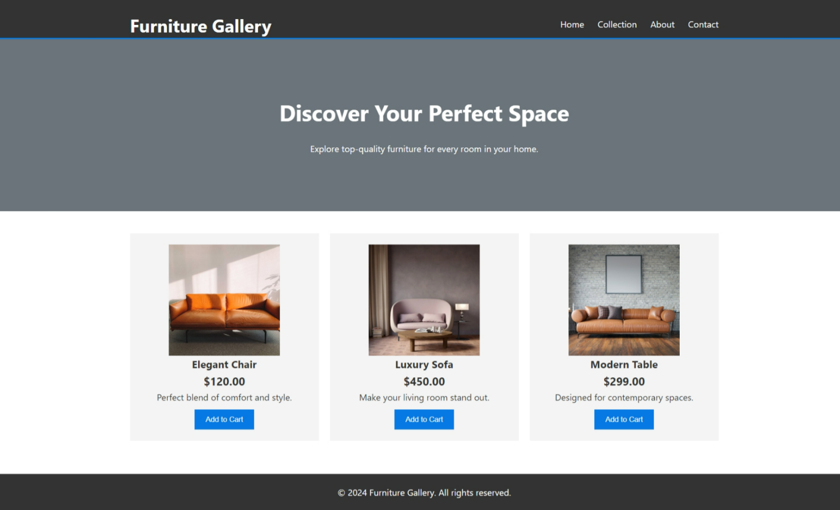

***Figure 9*** ***customised furniture homepage developed with ChatGPT 4.0***

# Section V: Experiments and Results

## AIM Tool for investigation and analysis

In the project, we utilise the AIM (Assessment of Interface Methodologies) tool to evaluate the efficacy of various generative AI algorithms for designing furniture website homepages. Uizard, Webador, ChatGPT 3.5, and ChatGPT 4.0 are examples of such tools. The AIM tool allows us to measure and analyse a variety of critical web page quality criteria, including visual appeal, usability, and design aesthetics. Spider diagrams are used to represent various parameters, providing a clear and comprehensive overview of the evaluation outcomes.

Spider diagrams illustrating how effectively each of these technologies fared in developing furniture internet interfaces, are displayed below for each homepage they created. These visualisations offer us with essential information about the benefits and drawbacks of each generative AI tool's output, allowing us to make more educated judgements and improve the design process for web pages.   
  
The spider diagrams provided below for each homepage created by these tools show how well they function while constructing furniture website interfaces. These visualisations offer us with essential information about the benefits and drawbacks of each generative AI tool's output, allowing us to make more educated judgements and improve the design process for web pages.

## Uizard Metrics Evaluation

***Figure 10 performance metrics of Uizard's homepage product showcase***

The spider chart for Uizard's Homepage 1 shows that the design performs particularly well in terms of Feature Congestion and Contour Density, indicating a clean layout with distinct features. Lower ratings for Colour Harmony and Colourfulness, on the other hand, indicate potential areas for improvement in the use of colour to increase user engagement and visual attractiveness.

***Figure 11 performance metrics of Uizard's homepage Blog Section***

Colour Harmony and NIMA perform quite well on the spider chart for Uizard's Homepage 2, showing that the design is both aesthetically pleasant and well-rated. Additionally, the design achieves good grades for Feature Congestion and Contour Congestion, indicating an ordered and straightforward arrangement that most likely improves user experience.

## Webador Metrics Evaluation

***Figure 12 performance metrics evaluation of Webador homepage***

The spider chart analysis of the Webador Homepage using the AIM tool reveals that the UI ranks top in Colour Harmony and WAVE, indicating a visually pleasing colour scheme and effective web accessibility. It has a 'Luminance SD' score of moderate, which indicates that the brightness variation is reasonable. However, Feature Congestion and Contour Congestion in the UI appear to require improvement, which may have an adverse effect on the user experience due to potential visual clutter.

## ChatGPT 3.5 Metrics Evaluation

***Figure 13 performance metrics evaluation of ChatGPT 3.5 homepage***

The spider chart for the Chatgpt 3.5 Home Page has excellent colour harmony and accessibility, as indicated by the high scores in these categories. The moderate rating for luminance standard deviation suggests that the design's handling of visual brightness was properly considered. The picture illustrates that feature and contour congestion can be reduced, implying that organisation is required to deliver an optimal user experience.

## ChatGPT 4.0 Metrics Evaluation

***Figure 14 performance metrics evaluation of ChatGPT 4.0 homepage***

The high scores in these categories suggest that the spider chart on the ChatGpt 4.0 Home Page is well-executed in terms of colour harmony and web accessibility criteria. The mid-range score for luminance standard deviation illustrates a systematic approach to the page's brightness and contrast. Nonetheless, the lower ratings for feature and contour congestion indicate that further refining the design may improve the user interface and experience.

## Exploring Saliency Detection Tool & Maps

The addition of a saliency tool into AI-generated home pages marks a big step forward in user experience analysis. The technique of developing heat maps for each home page enables a comprehensive investigation of user engagement patterns. This technique enables detailed analysis, allowing for well-informed design changes that optimise homepage layouts for improved efficiency and usability. This method can increase user pleasure and engagement in digital environments.

The saliency map directs design adjustments for greater effectiveness by highlighting the elements of a web page that people value the most. By highlighting crucial components such as text and images, it aids in the prioritisation and optimisation of web page layout to maximise user engagement.

## i.Uizard

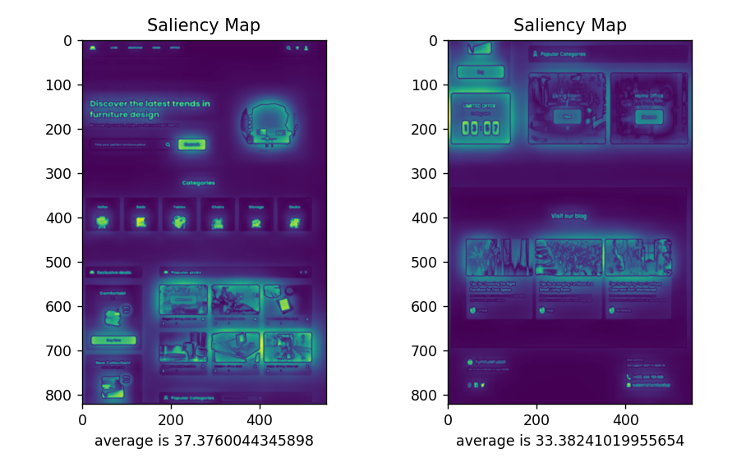

***Figure 15 Saliency Maps for UIzard Pages***

A detailed examination of the saliency maps for the homepage of a furniture website created by Uizard reveals that the product listings and search bar are the primary visual focal points. These listings have an average saliency of 37.37, indicating that they may serve as possible points of contact for visitors. The second map, with an average saliency of 33.38, highlights the Blog section's names and content headings. These maps provide UX designers with valuable input by highlighting regions of significant user interest and leading design modifications to improve the website's user experience.

## Webador

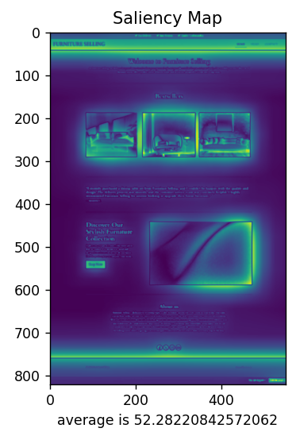

***Figure 16 Saliency Map for Webador Homepage***

The Webador-generated web page has a strong visual emphasis, as shown by the strong highlights and an average saliency score of 52.28, according to the saliency map. Users are likely to focus on this region, emphasising the importance of positioning significant products here to attract attention. The 'Shop Now' button is another noticeable piece that stands out from the background and could encourage users to act. These insights may be critical for carefully arranging content on the website to maximise user engagement and conversion.

## ChatGPT 3.5

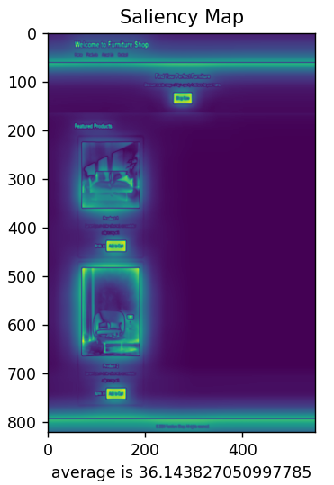

***Figure 17 Saliency Map for ChatGPT 3.5 Homepage***

The saliency map for the furniture website demonstrates that the model estimates a high amount of interaction with the navigation bar, featured product photos, and matching 'Add to Cart' buttons, with an average saliency score of 36.14. These features appear brighter on the map, indicating that users are more likely to notice them initially. This forecast could be attributed to the products' obvious imagery and noticeable positioning, both of which naturally grab the eye as potential purchases. The high placement of the navigation bar indicates how important it is for site navigation and user experience.

## ChatGPT 4.0

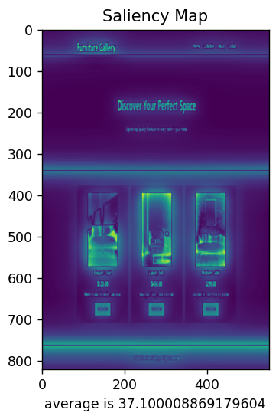

***Figure 18 Saliency Map for ChatGPT 4.0 Homepage***

The Furniture Gallery homepage GPT-4.0 saliency map shows that the featured products area and the central banner "Discover Your Perfect Space" have a strong visual attraction, with an average saliency score of 37.1. This means that viewers are more likely to notice the banner's eye-catching call-to-action, as well as the product details and photographs beneath it. Such saliency map focal spots indicate that the elements' arrangement and readability are effective in capturing users' attention, which is required to assist potential customers as they navigate the website's purchasing process.

## NIMA SCORE

***Table 1 NIMA Scores***

|  |  |  |  |
| --- | --- | --- | --- |
| ***No.*** | ***UI Versions of Furniture Home Page*** | ***NIMA Score*** | ***Evaluation*** |
| 1 | *Uizard Home page 1* | 5.0127 | Fair |
| 2 | *Uizard Home page 2* | 5.6425 | Fair |
| 3 | *Webador* | 6.0816 | Fair |
| 4 | *Chat Gpt 3.5* | 5.8081 | Fair |
| 5 | *Chat Gpt 4.0* | 5.5859 | Fair |

The NIMA ratings provide an aesthetic comparison of multiple furniture home page UI variants created with generative technologies such as Webador and Uizard. All of the versions are rated "Fair," but Webador has the highest grade of 6.0816, indicating that its design is somewhat more visually pleasing than the others. Despite being a more recent version, Chat Gpt 4.0 has a lower score of 5.5859 than the 3.5 version's 5.8081, indicating that the newer version's visual design has not improved. Section 1 and 2 of Uizard's home page have gradually improved, as indicated by an increase in scores from 5.0127 to 5.6425.

**Comparison between generative AI design metrics with saliency maps.**

When the spider chart data are contrasted to the saliency map analysis, an explanation appears about how good the AI technologies are in creating graphical user interfaces for furniture websites.   
  
Uizard's designs are basic, with possible user interaction points in the search bar and product listings, as demonstrated by the spider chart's high scores in 'Feature Congestion' and 'Contour Congestion'. The lower 'Colour Harmony' score on the spider chart may be additional proof that there is space for improvement in how people interact with the blog section, as suggested by the saliency map.   
  
Webador's home page design effectively draws users in by emphasising the header and call-to-action button. The better 'Colour Harmony' and 'NIMA' ratings on the spider chart support this, showing a pleasing colour scheme and overall visual appeal.   
  
ChatGPT 3.5's design stands out for its featured items and dynamic navigation, both of which contribute to the high 'Feature Congestion' scores. Visually appealing components like these are likely to help 'Contour Congestion' perform successfully, but 'Colour Harmony' should be improved to attract and retain users' interest even more.

The central display and featured product part of ChatGPT 4.0 are visually appealing and relate to the higher 'Colour Harmony' ratings seen on its spider chart, according to the saliency study. Less emphasis than in the 3.5 version is given on "Feature Congestion" and "Contour Congestion," indicating a more balanced approach to feature richness and clarity.   
  
In conclusion, while both Uizard and Webador are skilled at creating visually beautiful and fascinating designs, there is a noticeable difference in how colour is handled and understood in user interfaces. The saliency maps and spider chart metrics reveal that ChatGPT versions favour clear navigation and product feature display, but there is still room for improvement in visual impact and colour usage.

# Project Monitoring, Planning & Reflection

## SMART Objective

The research project investigates how generative AI may improve interface designs. It aims to make interfaces more usable, effective, and visually appealing. To do this, the initiative addresses a number of critical goals. First, it requires using generative AI technologies to create better interface prototypes. Second, it includes generative AI analytical tools for evaluating interface performance in a variety of fields, including usability and aesthetics. Third, the project uses findings from generative AI technologies to automate design improvement. The initiative aims to continuously enhance interface designs for the ideal user experience by analysing data and user feedback. This paper provides recommendations for successfully incorporating generative AI tools into future design processes, as well as insights into how generative AI might alter interface design.

## Project Plan

A complete plan, as well as a detailed Gantt chart, have been created to guide the inquiry into the potential of generative AI in interface design. This plan comprises activities such as performance evaluation, design refinement, prototype development, and literature review. The initiative claims to produce innovative advancements in interface design by giving insights and recommendations for the seamless integration of generative AI and strategic execution.

* **October**

**Weeks 1 to 5**: Analysed existing literature on AI in UI design, including methodology and study findings. To synchronise project goals and objectives, schedule and carry out the initial meeting with the supervisor.

* **November:**

**Weeks 6 to 9:** AI generative techniques were employed to develop UI prototypes with new functionality and design (Weeks 6-9). Experimented with several AI generative algorithms to investigate a wide range of design ideas.

* **December:**

**Weeks 10 to 12:** Integrated AI analytical techniques for design improvement and performance evaluation. examined how effectively AI analytical tools provide insights for better user interface design.

* **January:**

**Weeks 13 to 16:** Analysed AI-generated interfaces for usability and user satisfaction. Conducted comparison analysis utilising analytical tools to evaluate AI's effectiveness in UI design.

* **February:**

**Weeks 17 to 20:** Thorough analysis of AI analytical tools results. Opinions and ideas were expressed regarding the tools' performance and significance for the user interface.

* **March:**

**Weeks 21 to 25:** Focus on project documentation and term 1 report, including research findings, analyses, and conclusions. Developed comprehensive reports and presentations to effectively communicate project outcomes.

.

* **April:**

**Weeks 26 to 30:** Finished project and produced all essential documentation, such as reports and presentations. Project deliverables were submitted by the deadline.

## Gantt Chart

***Figure 19 Gantt Chart***

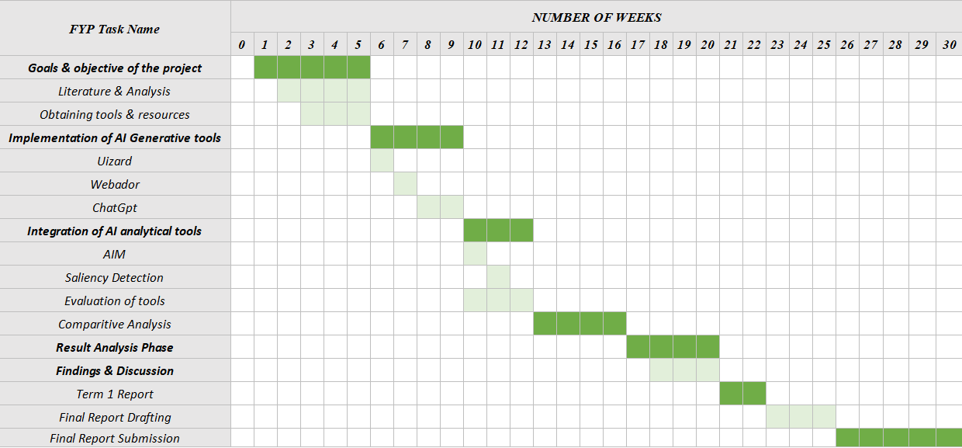

## Project Break down Structure (PBS)

The picture below shows the breakdown, with a Project Breakdown Structure (PBS) listing each of the phases required to create a comprehensive report. This thorough strategy ensures that each task is completed before moving on to the next, allowing for efficient project management.

***Figure 20 PBS Diagram***

This project carefully organised the incorporation of generative AI into user interface (UI) design, using the Product Breakdown Structure (PBS) as a guidepost. The project, which aimed to improve UI creation utilising AI technologies such as Uizard, Webador, and ChatGPT versions 3.5 and 4.0, was carefully planned and carried out in accordance with the PBS's stated steps.   
  
The project began with a thorough review of existing literature, which provided a solid foundation for understanding the relationship between AI and UI design. Then, generative AI methods were employed to produce user interface prototypes, each tailored to the complicated requirements of a platform for selling custom furniture. The Term 1 Report and early project drafts also provided documentation of this inquiry, including the discoveries and advancements made.   
  
Saliency maps, NIMA, and AIM are three examples of AI analytical techniques used in the research and assessment phase to critically evaluate UI designs. These evaluations focused on usability and visual appeal, which are critical for improving user interaction and satisfaction. The outcomes of this phase were carefully analysed, with a particular emphasis on the tools' comparative analysis, which was reflected in the final report draft.   
  
Regular monitoring throughout the project ensured that deadlines were met, allowing for a closer examination of each study goal. Time was intentionally allocated to allow for thorough tool experimentation, hence preventing biases and ensuring fair outcomes. Furthermore, SMART objectives and the project plan led project reflections and monitoring, identifying potential areas for future development and research in AI-powered UI design.   
  
Finally, the project adhered strictly to the PBS, ensuring that all phases were completed methodically, from early research and prototype development to analysis and final report authoring. AI-enhanced iterative design and evaluation methods encouraged unique user interface concepts and produced insightful data on their effectiveness, all of which were presented in a comprehensive final report that incorporated all lessons learned.

# Section V: Discussion

This study looked at how AI may shape the future of user interface design, using cutting-edge tools like Webador, ChatGPT, and Uizard. It investigated design effectiveness utilising AIM, NIMA, and saliency detection instead of traditional surveys, providing a new viewpoint on what people might find appealing. This approach proved AI's huge potential to not only reduce design labour but also improve the originality and visual appeal of interfaces, despite some limitations, particularly AIM's dependability. This opens up exciting opportunities for AI in design, demanding a thorough investigation into how such tools might build truly extraordinary user interfaces. This work adds to our understanding of how AI might affect user interface design and promotes more research into employing AI to create intuitive and captivating interfaces.   
  
The three AI tools investigated in this project—Webador, ChatGPT, and Uizard—each make a unique contribution to the user interface (UI) system by providing solutions to specific aspects of the design process. Although these technologies considerably improve design accessibility and efficiency, they also highlight the importance of human creativity and expertise in developing high-quality user interface design.

## I.Uizard: Revolutionizing Rapid Prototyping

The generative tool Uizard was essential for the design and implementation of a user interface for a furniture website. It generated wire frames efficiently, which is important for UI development, thanks to its AI-driven design capabilities. The pictures illustrates Uizard's design of numerous wireframe models, including a homepage display (Figure 1), a product category section (Figure 2), and a blog display page (Figure 3). Each is carefully planned to create an orderly and accessible website layout.   
  
The homepage design (Figure 5) and instructive blog section (Figure 6) show the evolution from wire frames to entire user interfaces, with powerful algorithms translating basic outlines into engaging, user-focused pages. Despite its strong capacity to connect concepts with the user experience, Uizard's reliance on specified templates can limit creative freedom, increasing the likelihood of an identical design approach. However, the platform's capacity to accelerate the design process from start to finish demonstrates its utility in UI development for e-commerce.   
  
Uizard's AI-generated designs strike the perfect balance between usefulness and visual aesthetics. The blog area (Figure 6) makes great use of colour to improve content readability and visual engagement. However, an urge to repeat patterns caused by reliance on fixed templates may limit the production of new designs, thereby damaging brand originality. Nonetheless, the careful use of colour and careful layout structure seen in the homepage design (Figure 5) demonstrates Uizard's capacity to provide market-compatible interfaces while suggesting the need for greater creative flexibility in future variations.   
  
To refine and fine-tune the user interface, powerful AI analytical methods such as AIM, saliency maps, and NIMA were employed to assess Uizard's designs. These evaluations share information on design performance, highlighting areas for improvement such as colour harmony, feature congestion, and contour density. The analytical phase identified the UI's strengths and places for improvement, proving AI's capacity to improve user experience while also contributing to the ongoing UI design process.

## I.Webador: Simplifying Web Design for All

The user interface for a furniture-selling website was created using Webador, a homepage builder that focuses on homepage design. Webador efficiently converted the input details into an actual model, as demonstrated by the design result (Figure 7). The final product was a homepage that merged appearance and utility while representing the design objectives.   
  
The colour scheme in Webador's homepage design (Figure 7) creates a consistent look that matches the shown furniture, resulting in a pleasant user experience. However, while Webador can generate clean and practical designs, its limitations are apparent. The platform's reliance on predefined templates can lead to a lack of design originality and may not suit specialist or customised branding requirements. Furthermore, modification choices are typically limited, which can hinder innovative design approaches and result in a generic user experience that does not completely reflect the brand's unique personality.   
  
To address and reduce these limits, AI analytical methods were employed to thoroughly evaluate the UI design. These tools assessed important design features such as colour harmony, graphic hierarchy, and user engagement metrics. The findings of this research were crucial in identifying places where the user interface may be modified to not only improve aesthetic appeal but also give a more customised and memorable user experience, showing the possibility of a deeper, more adaptive design approach.

## ChatGPT: Bridging Design and Development

As illustrated in this project, the ChatGPT webpage highlighted the tool's numerous functionalities. According to Zhang et al. (2022), its powerful neural framework enables it to process a wide range of inputs and provide exceptionally tailored answers, resulting in a better and more satisfying user experience. ChatGPT was built in two stages, beginning with unsupervised initial training and moving to supervised fine-tuning, as described by Radford et al. (2019).   
  
In this study, ChatGPT 3.5 was used to create HTML and CSS code for a custom furniture purchasing portal. This AI model's site shows an understanding of web design principles, with a basic style and a focus on product showing (Figure 8). The initial code produced from ChatGPT 3.5 was left unchanged to test the AI's ability to understand user needs on the first try. Although there is space for change based on user preferences, the decision to stick with the original code highlights the model's ability to produce a functioning and visually appealing interface right away.   
  
While ChatGPT 3.5 generated a technically sound and user-friendly navigation system, it has several limitations, including a lack of sophisticated design customisation and possible difficulty interpreting more subtle user design requirements. Despite these restrictions, ChatGPT 3.5 shows how artificial intelligence may greatly speed up the building of user interfaces by converting design briefs into clean, organised code that effectively showcases product aspects.   
  
Moving on to ChatGPT 4.0, the study used its advanced features to create an intelligent internet-based furniture business site. ChatGPT 4.0's refined understanding of user interaction and web aesthetics is apparent in the homepage it created (Figure 9), which features easy navigation and a clean design that complements the modern furniture style it represents. The model's complex characteristics, such as increased context comprehension and style flexibility, resulted in an even more intuitive and visually appealing interface.   
  
While ChatGPT 4.0 is a significant upgrade over its predecessor, allowing for more complex and user-friendly designs, it still has limits. These include a predefined design approach that may not adequately represent each brand's distinctiveness, as well as the necessity for human monitoring to customise the created UI to specific user needs. Nonetheless, ChatGPT 4.0 demonstrates the power of AI in developing UI design, providing effective tools for creating interfaces that captivate consumers and improve their browsing experience.

## I. Aalto Interface Metrics (AIM)

The AIM tools evaluates Uizard's created homepage and finds structural strengths, as shown by high Feature Congestion and Contour Density scores in the spider diagram (Figure 10). It does, however, identify possibilities to increase user interaction by increasing colour harmony and vibrancy. Uizard, while adept at arranging items, might benefit from better colour utilisation for a more lively UI.   
  
Webador's study with AIM reveals a visually appealing colour scheme with good accessibility, as shown by high Colour Harmony and WAVE scores in the spider diagram (Figure 12). The platform retains appropriate brightness variation, but also highlights the need for greater organisation to reduce visual clutter and improve the user experience.   
  
The ChatGPT 3.5 homepage design (Figure 13) exhibits proficiency in colour harmony and web accessibility. The design's careful balance of brightness is a plus, however the AIM tool advises that the arrangement of features and curves may be improved, showing the possibility of greater organisation.   
  
Similarly, the ChatGPT 4.0 webpage demonstrates effective colour harmony and accessibility compliance (Figure 14). Its brightness contrast is well-managed, but the lower ratings for feature and contour organisation indicate that a more streamlined arrangement could improve user interface clarity.   
  
The AIM evaluations reveal that, while these AI tools succeed in some elements of design, they share limits in element organisation and visual depth, indicating a potential area for AI improvement in producing more subtle and engaging UI designs.

## I. Saliency Tool

In this study, the saliency tool was utilised to learn more about how people engage with AI-generated homepages. A saliency tool predicts which elements of a webpage will attract the viewer's attention first by generating a visual heat map of the locations where a user's gaze may remain.   
  
The saliency detection tool's application on Uizard's homepage (figure 15) shows a considerable emphasis on the search bar and product listings, as well as significant attention to blog titles and headers, indicating that these are important interaction areas. Despite this, there is still potential for growth in visual engagement across the site, since the tool may neglect less apparent but critical page features.   
  
Webador's homepage (figure 16) examination gives a high saliency score for featured products and the 'Shop Now' button, indicating that they are effective at attracting user attention. However, the tool could fail to properly represent the influence of interactivity or dynamic content on user behaviour, which is essential for a total design approach.   
  
The furniture homepage developed using ChatGPT 3.5 has strong interaction (figure 17) with navigation and product selections, indicating a user-friendly design. Nonetheless, the saliency map might benefit from adding user interaction with textual content and secondary navigation features, both of which are necessary for deep user involvement.   
  
The prominent banners and product sections are the focus areas of ChatGPT 4.0's site (figure 18), showing how well these elements get noticed. However, the tool's insights may not encompass the whole user journey, including the essential steps from attraction to action that resulted in conversions.  
  
The saliency tool accurately identifies the main sources of user interest on AI-generated homepages, leading significant design improvements. However, it also highlights a typical flaw: a potential underestimating of the complexity of user interactions, underlining the need of designs that interest people beyond their first impression.

## I. Neural Image Assessment (NIMA)

In our study, the NIMA tool played an important role in judging the aesthetic appeal of AI-generated homepages by providing a numerical value to subjective qualities. Uizard's design appeal improved, however both versions remained in the 'Fair' category under NIMA guidelines. Webador's design stood out, obtaining the highest score, indicating a more harmonious mix of features that align with aesthetic tastes. Despite its expanded features, ChatGPT 4.0 did not obtain the same high rating as its predecessor, demonstrating that implementing user-centric design changes does not always result in higher aesthetic value.   
  
While NIMA is an interesting metric, it has some drawbacks. Its ratings are based on broad beauty criteria and may not take into consideration local or contextual design preferences unique to certain audiences or design goals. As a result, while NIMA scores are useful, they only cover one component of the entire evaluation required to fine-tune user interfaces for the best user experience.

# Section VI: Conclusion

In this research, a set of generative AI tools was employed to track the progress of user interface design on a furniture-selling site. These technologies, which were critical for their novel automation and analytical capabilities, contributed significantly to speeding the design process, improving user experience, and increasing visual appeal. The project was founded on goals of combining AI to build interfaces that are not only physically stunning, but also highly usable and entertaining.

## Objectives Achieved

Key goals included leveraging AI for design creation and assessment, as well as dedicating to refining interfaces with AI-driven insights and feedback mechanisms, thereby creating a new standard for digital design efficiency and effectiveness. Building on these foundations, the project's implementation clearly highlighted the achievement of its primary goals, emphasising the actual benefits of merging generative AI tools and analytical approaches into reconsidering interface design for the digital era.

* Using AI tools like Uizard, Webador, and ChatGPT produced high-quality interface prototypes, highlighting AI's capacity to enhance design efficiency and aesthetics. This method shortened the design process, demonstrating AI's innovative impact on improving user experience and design standards.
* The project utilised AI analytical methods (AIM, NIMA, and saliency maps) to evaluate and improve interface designs for usability, visual appeal, and user engagement. This technique enables informed design modifications, emphasising AI's vital role in improving user interfaces using data-driven insights.
* Using AI insights to automate design changes led to more clear and engaging interfaces. This process shows the effective use of AI into growing design practices, resulting in ongoing interface enhancement based on analytical assessments and user feedback.

This research did not gather user feedback because its primary purpose was to assess the features and limitations of both analytical and generative AI tools in interface design. The major purpose was to better understand their potential and find areas for development in automating design methods and enhancing user interface quality through objective analysis rather than subjective user feedback.   
  
Uizard uses templates, which may limit design individuality. Webador's simplicity may restrict advanced customisations. GPT 3.5 and 4.0 may not fully grasp UI/UX specifics, resulting in outputs that require modification. AIM, NIMA, and saliency maps are analytical methods with limits for qualitative research, cultural details, and user interaction situations. Future enhancements should focus on personalisation and understanding user-focused design concepts for these products.

Uizard (Uizard updates, 2024) has made major improvements in improving its interface design capabilities with a number of changes. Notably, it contains Autodesigner 1.5, which allows users to rapidly turn textual descriptions into UI mock-ups, marking a move towards more fluid ideation. The integration of keyboard shortcuts with industry standards, as well as better text copying functionality, boosts user productivity. These additions, along with an enhanced comments system and the ability to import Figma designs, improve Uizard's capacity to accelerate UI design processes for current and future projects.   
  
Unlike Uizard, Webador (Create a free website - Webador, n.d.) has not publicly announced any new features. Webador focuses on user-friendly design components and adaptable templates that appeal to a diverse variety of users, from beginners to experts. Future Webador upgrades are expected to improve the web design process, making it easier for users to develop and manage their online presence. These planned enhancements could enable UI/UX designers to create more dynamic and user-friendly products.

OpenAI (openai.com, n.d.) enhanced GPT-3.5's improving capabilities and enlarged the possibilities for building custom models. New features such as epoch-based point creation and extensive validation metrics provide you greater control over model training, increasing efficiency and accuracy. Assisted fine-tuning, as part of a bespoke model programme, provides collaborative support for model optimisation. These developments, together with third-party integration support and an easy-to-use dashboard, allow developers to tune AI models to specific domains, enhancing their relevance and effect across a wide range of applications.   
  
OpenAI (openai.com, n.d.) has greatly improved GPT-4, including new fine-tuning facilities for more precise model customisation and third-party integration capabilities. These additions are intended to quicken developers' workflows and allow for greater model customisation, hence improving performance for specific jobs or sectors.

# References

Alqaraawi, A., Schuessler, M., Weiß, P., Costanza, E. and Berthouze, N. (2020). Evaluating saliency map explanations for convolutional neural networks. Proceedings of the 25th International Conference on Intelligent User Interfaces. [online] doi:https://doi.org/10.1145/3377325.3377519.

‌

Antti Oulasvirta, Samuli De Pascale, Koch, J., Langerak, T., Jokinen, J., Kashyap Todi, Laine, M., Manoj Kristhombuge, Zhu, Y., Aliaksei Miniukovich, Palmas, G. and Weinkauf, T. (2018). Aalto Interface Metrics (AIM). Aaltodoc (Aalto University). doi:https://doi.org/10.1145/3266037.3266087.

Brownlee, J. 2021, 'How to Develop a GPT-2 Text Generator in Python', Machine Learning Mastery. Available at: <https://machinelearningmastery.com/how-to-develop-a-generative-model-for-text-generation-in-python/> (Accessed: 26 April 2023).‌

Create a website for free - Webador. (n.d.). Webador: #1 Create a free website with domain. [online] Available at: <https://www.webador.co.uk/?ga.>

Cen, C., Luo, G., Li, L., Liang, Y., Li, K., Jiang, T. and Xiong, Q. (2023). User-Centered Software Design: User Interface Redesign for Blockly–Electron, Artificial Intelligence Educational Software for Primary and Secondary Schools. Sustainability, 15(6), p.5232. doi:https://doi.org/10.3390/su15065232.

Duvaud, S., Gabella, C., Lisacek, F., Stockinger, H., Ioannidis, V. & Durinx, C., 2021. Expasy, the Swiss Bioinformatics Resource Portal, as designed by its users. Nucleic Acids Research, 49, W216–W227.‌

Gonçalves, M., Nunes, A. and Oliveira, A. (n.d.). *THE IMPACTS OF AI ON CREATIVE PROCESSES IN UX/UI PROJECT DEVELOPMENT: A COMPREHENSIVE REVIEW OS IMPACTOS DA IA NOS PROCESSOS CRIATIVOS NO DESENVOLVIMENTO DE PROJETOS UX/UI: UMA REVISÃO ABRANGENTE*. [online] Available at: https://pdf.blucher.com.br/engineeringproceedings/siintec2023/305955.pdf [Accessed 12 Feb. 2024].

Hegemann, L., Jiang, Y., Shin, J., Liao, Y.-C., Laine, M. and Antti Oulasvirta (2023). Computational Assistance for User Interface Design: Smarter Generation and Evaluation of Design Ideas. doi:https://doi.org/10.1145/3544549.3583960.

Hou, X. and Zhang, L. (2007). Saliency Detection: A Spectral Residual Approach. 2007 IEEE Conference on Computer Vision and Pattern Recognition. doi:https://doi.org/10.1109/cvpr.2007.383267.

‌

‌

interfacemetrics.aalto.fi. (n.d.). AIM - Aalto Interface Metrics service. [online] Available at: <https://interfacemetrics.aalto.fi/.>

ieeexplore.ieee.org. (n.d.). IEEE Xplore Full-Text PDF: [online] Available at: https://ieeexplore.ieee.org/stamp/stamp.jsp?tp=&arnumber=8352823.

Kurzantseva, L.I., 2007. About creation of the intelligent interface of a computer system with properties of adaptation. Computer Means, Networks and Systems. Kiev: National Academy of Sciences of Ukraine, Institute of Cybernetics them. VM Glushkov National Academy of Sciences of Ukraine, 6, pp.104–110.

Lieberman, H. (2009). User Interface Goals, AI Opportunities. *AI Magazine*, 30(4), p.16. doi:https://doi.org/10.1609/aimag.v30i4.2266.

Lapuschkin, S., Wäldchen, S., Binder, A., Montavon, G., Samek, W. & Müller, K.-R., 2019. Unmasking Clever Hans predictors and assessing what machines really learn. Nature Communications, 10(1), 1096. Available at: <https://doi.org/10.1038/s41467-019-08987-4>.

Macik, M. (n.d.). User interface generator. Retrieved from <https://www.researchgate.net/profile/Miroslav-Macik/publication/228680265_User_interface_generator/links/00463522ee6144642f000000/User-interface-generator.pdf>

Norman, D.A. & Draper, S.W., 1986. User Centered System Design: New Perspectives on Human-Computer Interaction. Erlbaum: Hillsdale, NJ, USA.

Nah, F.F.-H., Zheng, R., Cai, J., Siau, K. and Chen, L. (2023). Generative AI and ChatGPT: Applications, challenges, and AI-human collaboration. Journal of information technology case and application research, 25(3), pp.1–28. doi:https://doi.org/10.1080/15228053.2023.2233814.

OpenAI (2023). GPT-4. [online] openai.com. Available at: <https://openai.com/gpt-4.>

‌

OpenAI (2023). *ChatGPT-3.5*. [online] openai.com. Available at: <https://openai.com/chatgpt.>

openai.com. (n.d.). Introducing improvements to the fine-tuning API and expanding our custom models program. [online] Available at: https://openai.com/blog/introducing-improvements-to-the-fine-tuning-api-and-expanding-our-custom-models-program

‌

OMG Standard: Query View Transformation 2010, last visited 22 February 2010, [http://http://www.omg.org/spec/QVT/1.0/](http://http//www.omg.org/spec/QVT/1.0/).

Ruiz, C. & Quaresma, M., 2021. Inovação com dados: A experiência do usuário com sistemas base em inteligência artificial. Human Factors in Design, 10(20), pp.23-44. Available at: <https://doi.org/10.5965/2316796310202021023>

Rosebrock, A. (2018). OpenCV Saliency Detection. [online] PyImageSearch. Available at: https://pyimagesearch.com/2018/07/16/opencv-saliency-detection/.‌

Ribeiro, M.T., Singh, S. & Guestrin, C., 2016. "Why Should I Trust You?": Explaining the Predictions of Any Classifier. In: Proceedings of the 22nd ACM SIGKDD International Conference on Knowledge Discovery and Data Mining (KDD ’16). New York, NY, USA: ACM, pp. 1135–1144. Available at: <https://doi.org/10.1145/2939672.2939778.>

Roumeliotis, K.I. and Tselikas, N.D. (2023). ChatGPT and Open-AI Models: A Preliminary Review. Future Internet, [online] 15(6), p.192. doi:https://doi.org/10.3390/fi15060192.

Radford, A., Wu, J., Child, R., Luan, D., Amodei, D. & Sutskever, I. 2019, 'Language Models Are Unsupervised Multitask Learners', OpenAI Blog. Available at: https://life-extension.github.io/2020/05/27/GPT%E6%8A%80%E6%9C%AF%E5%88%9D%E6%8E%A2/language-models.pdf (Accessed: 26 April 2023).

Talebi, H. and Milanfar, P. (2018). NIMA: Neural Image Assessment. IEEE Transactions on Image Processing, 27(8), pp.3998–4011. doi:https://doi.org/10.1109/tip.2018.2831899.

‌

uizard.io. (n.d.). Uizard. [online] Available at: <https://uizard.io/.>

Uizard updates. (2024). Uizard updates. [online] Available at: https://updates.uizard.io/?_gl=1

Van Den Bergh, J., Sauer, S., Breiner, K., Hußmann, H., Meixner, G., Pleuss, A. and Lero (2010). 5 th International Workshop on Model Driven Development of Advanced User Interfaces (MDDAUI 2010) Bridging between User Experience and UI Engineering Proceedings. [online] Available at: https://ceur-ws.org/Vol-617/MDDAUI2010_FinalProceedings.pdf#page=31 [Accessed 12 Feb. 2024].

‌

Zubkova, T. and Tagirova, L. (2019). Intelligent user interface design of application programs. *Journal of Physics: Conference Series*, 1278, p.012026. doi:https://doi.org/10.1088/1742-6596/1278/1/012026.

Zhang, Y., Sun, S., Galley, M., Chen, Y.-C., Brockett, C., Gao, X., Gao, J., Liu, J. & Dolan, B., 2022. Dialogpt: Large-scale generative pre-training for conversational response generation. arXiv, [eprint] arXiv:1911.00536.#

# Related Links

The following link will redirect to the github repository that contains all used source codes of both versions of GPT and the saliency tool used:

<https://github.com/saimrao00/final-year-project-repository.git>

# Appendix 1: ChatGpt 4.0

The following is the user interface code for a furniture selling website generated with ChatGPT 4.0. This code uses advanced HTML and CSS to provide a visually appealing and user-friendly surfing experience.

**HTML Code:**

<!DOCTYPE html>

<html lang="en">

<head>

    <meta charset="UTF-8">

    <meta name="viewport" content="width=device-width, initial-scale=1.0">

    <title>Furniture Gallery</title>

    <link rel="stylesheet" href="style.css">

</head>

<body>

    <header>

        <div class="container">

            <h1>Furniture Gallery</h1>

            <nav>

                <ul>

                    <li><a href="#">Home</a></li>

                    <li><a href="#">Collection</a></li>

                    <li><a href="#">About</a></li>

                    <li><a href="#">Contact</a></li>

                </ul>

            </nav>

        </div>

    </header>

    <main>

        <section class="hero">

            <div class="container">

                <h2>Discover Your Perfect Space</h2>

                <p>Explore top-quality furniture for every room in your home.</p>

            </div>

        </section>

        <section class="products">

            <div class="container grid">

                <div class="product-card">

                    <img src="sofa.png" alt="Elegant Chair">

                    <h3>Elegant Chair</h3>

                    <p class="price">$120.00</p>

                    <p>Perfect blend of comfort and style.</p>

                    <button>Add to Cart</button>

                </div>

                <div class="product-card">

                    <img src="sofa1.png" alt="Luxury Sofa">

                    <h3>Luxury Sofa</h3>

                    <p class="price">$450.00</p>

                    <p>Make your living room stand out.</p>

                    <button>Add to Cart</button>

                </div>

                <div class="product-card">

                    <img src="sofa2.png" alt="Modern Table">

                    <h3>Modern Table</h3>

                    <p class="price">$299.00</p>

                    <p>Designed for contemporary spaces.</p>

                    <button>Add to Cart</button>

                </div>

            </div>

        </section>

    </main>

    <footer>

        <div class="container">

            <p>&copy; 2024 Furniture Gallery. All rights reserved.</p>

        </div>

    </footer>

</body>

</html>

**CSS Code:**

* {

*box-sizing*: border-box;

*margin*: 0;

*padding*: 0;

}

body {

*font-family*: 'Segoe UI', Tahoma, Geneva, Verdana, sans-serif;

*line-height*: 1.6;

*color*: #333;

}

.container {

*max-width*: 1100px;

*margin*: auto;

*padding*: 0 20px;

}

header {

*background*: #333;

*color*: #fff;

*padding-top*: 20px;

*min-height*: 70px;

*border-bottom*: #0779e4 3px solid;

}

header h1 {

*float*: left;

}

header nav {

*float*: right;

*margin-top*: 10px;

}

header nav ul {

*list-style*: none;

}

header nav ul li {

*display*: inline;

*margin-left*: 20px;

}

header nav ul li a {

*color*: #fff;

*text-decoration*: none;

}

.hero {

*background*: rgb(108, 116, 123);

*color*: #fff;

*padding*: 100px 0;

*text-align*: center;

}

.hero h2 {

*font-size*: 40px;

*margin-bottom*: 20px;

}

.products {

*padding*: 40px 0;

}

.grid {

*display*: grid;

*grid-template-columns*: repeat(3, 1fr);

*grid-gap*: 20px;

}

.product-card {

*background*: #f4f4f4;

*padding*: 20px;

*text-align*: center;

}

.product-card img {

*width*: 200px;

*height*: 200px;

*object-fit*: cover;

*display*: block;

*margin*: auto;

}

.price {

*color*: #333;

*font-size*: 20px;

*font-weight*: bold;

}

button {

*display*: inline-block;

*background*: #0779e4;

*color*: #fff;

*padding*: 10px 20px;

*border*: none;

*cursor*: pointer;

*margin-top*: 10px;

}

button:hover {

*background*: #6a7b8b;

}

footer {

*background*: #333;

*color*: #fff;

*text-align*: center;

*padding*: 20px;

*margin-top*: 20px;

}

@media (*max-width*: 768px) {

    .grid {

*grid-template-columns*: 1fr;

    }

    header h1, header nav {

*float*: none;

*text-align*: center;

    }

    header nav ul {

*margin-top*: 0;

    }

}

# Appendix 2: ChatGpt 3.5

The code below represents the user interface for a furniture sales website generated by ChatGPT 3.5. It uses HTML and CSS code to create a visually appealing and functional design.

**HTML Code:**

<!DOCTYPE html>

<html lang="en">

<head>

    <meta charset="UTF-8">

    <meta name="viewport" content="width=device-width, initial-scale=1.0">

    <title>Furniture Shop</title>

    <link rel="stylesheet" href="styles.css">

</head>

<body>

    <header>

        <div class="container">

            <h1>Welcome to Furniture Shop</h1>

            <nav>

                <ul>

                    <li><a href="#">Home</a></li>

                    <li><a href="#">Products</a></li>

                    <li><a href="#">About Us</a></li>

                    <li><a href="#">Contact</a></li>

                </ul>

            </nav>

        </div>

    </header>

    <section class="hero">

        <div class="container">

            <h2>Find Your Perfect Furniture</h2>

            <p>Discover a wide range of high-quality furniture for your home.</p>

            <a href="#" class="btn">Shop Now</a>

        </div>

    </section>

    <section class="products">

        <div class="container">

            <h2>Featured Products</h2>

            <div class="product">

                <img src="sofa.png" alt="Product 1">

                <h3>Product 1</h3>

                <p>Lorem ipsum dolor sit amet, consectetur adipiscing elit.</p>

                <span class="price">$199.99</span>

                <a href="#" class="btn">Add to Cart</a>

            </div>

            <div class="product">

                <img src="sofa1.png" alt="Product 2">

                <h3>Product 2</h3>

                <p>Lorem ipsum dolor sit amet, consectetur adipiscing elit.</p>

                <span class="price">$299.99</span>

                <a href="#" class="btn">Add to Cart</a>

            </div>

            <!-- Add more product divs as needed -->

        </div>

    </section>

    <footer>

        <div class="container">

            <p>&copy; 2024 Furniture Shop. All rights reserved.</p>

        </div>

    </footer>

</body>

</html>

**CSS Code:**

/* Reset CSS */

* {

*margin*: 0;

*padding*: 0;

*box-sizing*: border-box;

}

body {

*font-family*: Arial, sans-serif;

*line-height*: 1.6;

*background-color*: #f4f4f4;

*color*: #333;

*margin*: 0;

}

.container {

*width*: 80%;

*margin*: 0 auto;

}

header {

*background*: #333;

*color*: #fff;

*padding*: 1rem 0;

}

header h1 {

*margin*: 0;

}

nav ul {

*list-style*: none;

*padding*: 0;

}

nav ul li {

*display*: inline;

*margin-right*: 20px;

}

nav ul li a {

*color*: #fff;

*text-decoration*: none;

}

.hero {

*text-align*: center;

*padding*: 2rem 0;

*background*: #f4f4f4;

}

.products {

*background-color*: #fff;

*padding*: 2rem 0;

}

.product {

*width*: calc(33.33% - 40px);

*background*: #fff;

*margin*: 20px;

*padding*: 20px;

*border-radius*: 5px;

*box-shadow*: 0 0 10px rgba(0, 0, 0, 0.1);

*text-align*: center;

}

.product img {

*width*: 100%;

*border-radius*: 5px;

}

.product h3 {

*margin-top*: 1rem;

}

.product p {

*color*: #777;

}

.price {

*font-weight*: bold;

}

.btn {

*display*: inline-block;

*background*: #333;

*color*: #fff;

*padding*: 0.5rem 1rem;

*text-decoration*: none;

*border-radius*: 5px;

*margin-top*: 1rem;

}

.btn:hover {

*background*: #555;

}

footer {

*background*: #333;

*color*: #fff;

*padding*: 1rem 0;

*text-align*: center;

}

# Appendix 3: Saliency Code‌

The saliency code uses algorithms to identify areas of visual meaning in images.The saliency code uses the OpenCV library for carrying out mathematical operations related to visual saliency analysis (Hou and Zhang, 2007). Along with OpenCV, it uses the matplotlib, numpy, and skimage libraries to improve its functionality, providing an in-depth approach to saliency detection through effective calculation and visualising techniques. Following is the saliency code.

import cv2

import matplotlib.pyplot as plt

import numpy as np

*def* setup_display():

    plt.rc('axes', *labelsize*=20)

    return plt.figure(*figsize*=(40, 40))

*def* import_and_process_image(*path*):

    image = cv2.imread(*path*)

    image = cv2.resize(image, (550, 820))

    return cv2.cvtColor(image, cv2.COLOR_BGR2RGB)

*def* calculate_saliency(*image*, *saliency_detector*):

    success, saliency_map = *saliency_detector*.computeSaliency(*image*)

    return (saliency_map * 255).astype("uint8")

*def* process_images(*paths*):

    fig = setup_display()

    images = [import_and_process_image(path) for path in *paths*]

    saliency_detector = cv2.saliency.StaticSaliencyFineGrained_create()

    saliency_maps = [calculate_saliency(image, saliency_detector) for image in images]

    means = [np.mean(smap) for smap in saliency_maps]

    display_Heat_maps(fig, saliency_maps, means)

*def* display_Heat_maps(*fig*, *maps*, *means*):

    for i, (map, mean) in enumerate(zip(*maps*, *means*), 1):

        ax = *fig*.add_subplot(1, len(*maps*), i)

        ax.set_title('Saliency Map {}'.format(i))

        ax.set_xlabel('Average: {*:.2f*}'.format(mean), *fontsize*=10)

        ax.imshow(map)

    plt.subplots_adjust(*wspace*=0.5)

    plt.show()

*def* main():

    image_path1 = input('Enter the link to the first image file: ')

    image_path2 = input('Enter the link to the second image file: ')

    process_images([image_path1, image_path2])

if __name__ == "__main__":

    main()